# Laboratory Exercise 10

## Assignment 1

1_Code

2_Ket qua

## Assignment 2

1_Code

2_Ket qua

## Assignment 3

1_Code

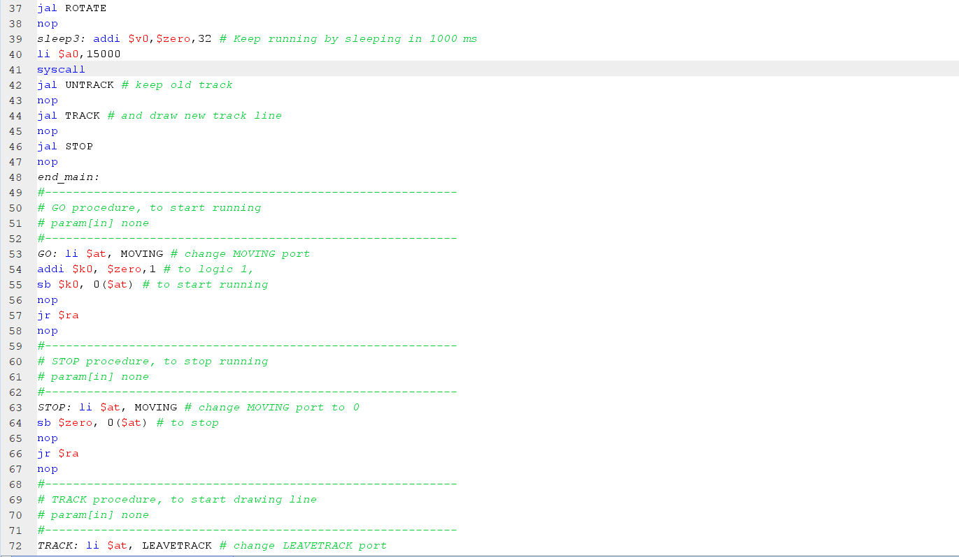

2_Ket qua

